Dyad Productions

|  |  |
| --- | --- |
| **TECHNICAL RIDER** | |
| Performance: | **AUSTEN’S WOMEN** |
| Performer: | Rebecca Vaughan (07957 381317) |

Please find included all information regarding the technical aspects of Austen’s Women.

**BASIC INFORMATION**

- AUSTEN’S WOMEN is a one-woman show, performed by REBECCA VAUGHAN. It is a compilation and adaptation of excerpts of the female characters in Jane Austen’s works.

- MS VAUGHAN will arrive at approx 2pm on the day of the performance.

This is a very intimate show, it should be played as far DS as possible.

Ms Vaughan will be pre-set on stage before the house opens. There will be a lit candle throughout the show. (please see attached risk assessment – Pg 3)

**CREW REQUIREMENTS**

This production does not tour with a technician and therefore requires:

- ONE in-house technician for the get in

- ONE technician to operate the show (if both LX and sound cannot be operated from the same position then 2 technicians will be required to operate the show) The show can be operated from a fully marked up script, provided on the day.

- ONE technician to help with the get-out

**RUNNING TIME**

70 mins straight through.

**SCENIC ELEMENTS**

The set includes (Please see photo on next page):

* a area rug measuring 3.5m (SL-SR) x 2.75m (US-DS)
* a small dressing table, with mirror and various props
* a chair
* a dressing screen

**The desired playing space is 6m x 5m.** If your stage is much larger than this, could you please hang a full black at approx 5m upstage., and arrange for masking to be hung to reduce the width of your stage to as close as possible to the desired width (6m) If your venue has a removable apron, please contact us regarding its position. If your venue has a static apron, Ms Vaughan will make a decision on arrival whether or not she will play on it.

**The absolute minimum playing space is 4m x 3m.**

This is a very intimate show, and as such we would really appreciate it if masking could be considered during the get-in of the show.

**LX REQUIREMENTS**

A warm general wash covering the playing space (**approx 4m wide x 3m deep** - to cover the playing space, without bleeding onto the masking) in chocolate (L156 if possible) Lit from front, sides, top and back.

There are 30 LX cues. **Please see attached sheet for graph plot** (pg 4). All lighting should be pre-rigged and rough focused before arrival. TTI would also appreciate it if you could programme all cues into the desk, so that only cue balancing will need doing on arrival.

**SOUND REQUIREMENTS**

Sound will be provided on the day of performance, on CD. It consists of Pre and post show music and 1 sound cue. (If possible we would prefer 2 CD players, although this is not absolutely necessary)

In larger venues (300+ seats) additional vocal amplification may be needed. (general stage mics will suffice)

**DRESSING ROOM REQUIREMENTS**

1 dressing room with tea/coffee & ironing facilities. Please ensure that the shower (if available) is clean and a fresh towel and soap are available.

**ADDITIONAL INFORMATION**

Please ensure that there is suitable parking for 1 car, which will be transporting the set.

Please provide vegetarian refreshments for 1 person (vegetarian sandwiches are fine) for approx 5pm.

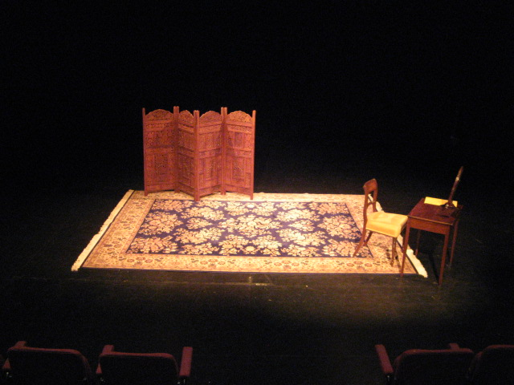

|  |  |  |  |  |  |  |  |  |  |  |  |  |  |
| --- | --- | --- | --- | --- | --- | --- | --- | --- | --- | --- | --- | --- | --- |
| Theatre Tours International (TTI)  Risk Assessment | | | | | | | | | | | | | |
| Performance | | Austen’s Women | | | | Updated: 24/09/09 | | | | | | | |
| Show Details  Austen’s Women is a one-woman show, which doesn’t comprise of any build set, or anything to be hung from your grid. TTI provide all furniture and props and do not tour any electrical equipment, or a touring technician, therefore all generic risk assessments (working at height/with electricity) should be covered by the venue. | | | | | | | | | | | | | |
| **Severity (S)** | | | **Likelihood (L)** | | | | **Risk Factor (S X L) = RF** | | | | | | |
| 1 – Negligible | | | 1 – Improbable | | | | 0 – 6 – LOW (improve if possible) | | | | | | |
| 2 – Minor Injury | | | 2 – Unlikely | | | |  | | | | | | |
| 3 – Lost time to injury | | | 3 – May occur | | | | 7 – 15 – MEDIUM (RF above 12 - further action required) | | | | | | |
| 4 – Major Injury | | | 4 – Possible/May occur | | | |  | | | | | | |
| 5 - Fatality | | | 5 – Very Likely | | | | 16 – 25 HIGH (Immediate action required) | | | | | | |
| **Description of Risk/Hazard** | | | | **People at Risk** | | **Initial Assessment** | | | | | | | |
|  | | | |  | | **S** | | **L** | | | **RF** | |  |
| 1 | Glass on stage. (carafe and glass), could be knocked over and broken | | | Performer | | 2 | | 3 | | | 6 | | LOW |
| 2 | Water on stage, Could be spilt causing a slip hazard. | | | Performer | | 2 | | 3 | | | 6 | | LOW |
| 3 | Naked flame on stage (candle) | | | Performer | | 4 | | 3 | | | 12 | | MEDIUM |
|  | | | | | | | | | | | | | |
| **Control Measures** | | | | | **Residual Risk** | | | | | | | | |
|  | | | | | **S** | | | | **L** | **RF** | |  | |
| 1 | The glass is used practically, and the action has been thoroughly rehearsed and is of an ‘everyday’ manner that would minimise any risk of breakage. Should the glass fall it would most likely land on the rug, minimising the risk of breakage. | | | | 2 | | | | 1 | 2 | | LOW | |
| 2 | If water is spilt it will likely be on the dressing table, eliminating the risk of a slip. | | | | 1 | | | | 1 | 1 | | LOW | |
| 3 | The candle is secured in a holder, which is placed on the corner of the desk. It will be lit by the performer before the audience enter. The performer will be present onstage for the duration of the time it is lit. It will be blown out at the end of the play. Should it fall off the desk, it would fall onto the stage floor, minimising the risk of it setting alight to anything. Should anything catch alight there is a carafe of water which can be used to extinguish any flames. | | | | 2 | | | | 2 | 4 | | LOW | |

|  |  |  |  |  |  |  |  |  |
| --- | --- | --- | --- | --- | --- | --- | --- | --- |
| **LIGHTING PROGRAMMING SHEET FOR AUSTEN'S WOMEN** | | | |  |  |  |  |  |
|  |  |  |  |  |  |  |  |  |
| Single Warm Wash from front, back & sides, soft edged to 12 inches from front and sides of Carpet and 1 meter to rear. | | | | | | | | |
| The General state is modulated to 50%, 70% & 100%. The number listed in the column below the percentage is the time in which the cue should occur. | | |  |  |  |  |  |  |
| Timings in seconds | |  |  |  |  |  |  |  |
|  |  | Percentage of state | | |  |  |  |  |
| **Cue #** |  | **50%** | **70%** | **100%** | **B/O** | **H/L** | **Wait** | **Follow** |
| **1** | **Preset** | **5 +** |  |  |  | **5 +** |  |  |
| **2** | **Clearance** |  |  |  |  | **Down over 10 secs** |  |  |
| **2a (on completion of LX 2)** |  |  | **10** |  |  |  |  |  |
| **3, 5, 9, 11, 13, 15, 17, 21, 23, 25, 27, 29** |  |  |  | **4** |  |  |  |  |
| **4, 6, 8, 10, 12, 14, 16, 18, 20, 22, 24, 26, 28** |  |  | **4** |  |  |  |  |  |
| **7** |  | **5** |  |  |  |  |  |  |
| **19** |  |  |  | **0** |  |  |  |  |
| **30** |  |  | **2** |  |  |  |  |  |
| **31** | **Close** |  |  |  | **10** |  |  | **12** |
| **33** | **Black Out** |  |  |  | **4** |  |  | **5** |
| **32, 34** | **Curtain Call 1, 2** |  |  | **5** |  |  |  |  |
| **35** | **Post Set** | **7 +** |  |  |  | **7 +** |  |  |